**Arduino Auditory Recognition Training System (Arduino ARTsy) Manual**

Written by Yow-Tyng (Tim) Yeh

04/05/2019

This updated training system replaces the old ARTsy, which uses the National Instruments Digital I/O card, with ***Arduino Mega 2560 microcontroller***. The new system not only allows more efficient modifications on software and hardware if needed, but also reduces the complexity of wiring scheme.

Several scripts are currently available with graphic user interface for different behavioral experiments. If you need to write a new customized script, please refer to the existing scripts for general programming logic and hardware control such infra-red sensor, relay control, solenoid, etc.

Below are the scripts that are currently available and have been tested with actual experiments:

* ***Housing***
* ***Song Training***
* ***Acclimate***
* ***Shaping***
* ***Go/No-go***
* ***Preference***

All the scripts and relevant files are inside the Arduino ARTsy folder on the desktop. (*C:\Users\labadmin\Desktop\Arduino ARTsy*)

**Housing**

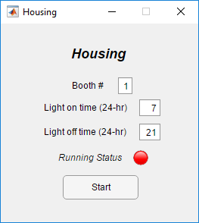

**Song Training**

**Acclimate**

This program allows the bird to acclimate to a moving feeder. The feeder will present seeds to the bird for a defined time period (reward duration) randomly between ITI min and ITI max. Once the bird learns to eat from the feeder, move on to ***Shaping*.**

- Enter booth number, ITI min, ITI max and reward duration

- Press the start button to start the program and the lamp will turn green

- To stop the script, close the GUI window and use CTRL + C to terminate

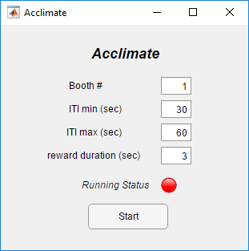

**Shaping**

**Go/No-go**

**Preference**